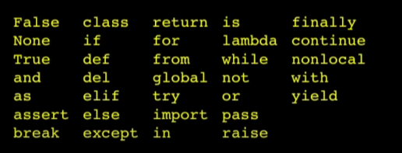

Reserved keywords

Input() – assignment value is given an input call that is given to the interpreter input then gets updated a value/data we put in.

Name = input(“givename”) print(name)

Input returns a string so change it to int if needed. Eg Floor = input(“enter data”) Usfloor = int(floor) + 1. Print(Usfloor) o/p – integer value

“=” is assignment operator and == is the “equal to”. The comparison operators are usually used to solve and asking questions and thereby getting those result in boolean ie True or False.

Also, it is usually used in if else while and other loop operations.

Try / except Structure – surround a dangerous section of your code with try and except. Also, if code in ‘try’ works then except is skipped. If code in try fails it jumps to except section.

2 types of fns – build in (like input(), type(), int()…) and other is the function that we define on our own. “Def” is a function block, it actually “ remembers” the code and it names it anything. So when “thing()” is called/invoked it goes up and runs your code.

Big() – biggest letter

Functions are basically remembering&store and THEN reuse WITH initiation/fn call. Eg max(). In backhand someone already wrote the fn for finding the character with many for loops and other stuff and then reads through other list and etc.

When we return a value in a function, then the returned value it should be assigned a variable so that that data can be used globally in the whole program.

Arguments can be passed inside a function. Eg. Greet(Lang) here lang is a place holder. When we do a fn call ie greet(‘en’) then lang is now a alias to ‘en’ then it is used inside the function. One more thing, basically, what we defined outside the function, that we initialized ie x and name should be used as arguments to be able to play with it.

Python you can explicitly iterate over a set of elements in a list, string or tuple but in other languages you need to provide indexing. Ie for i in [3,4,5] print(i)

Range [1,6] – generates a sequence from [1,2,3,4,5] but if we give print it outputs 1,2,3,4,5 downwards unless \n specified. Which is the same output as for I in [1,2,3,4,5]

Srtirp excess space – greet.strip() takes out space from left and right side of the given word but not inbetween the word.

File -> handle = open(“qle.txt”, ‘r’) ie variable that you store file handle = open file inside file name and opening mode read, write or append.

Variables – have only 1 value in them. So we now introduce, list – is a collection(can put lots of things to organize them like suitcases)

Range – returns a list of rumbers.eg; a= b,c,d. print(range(a)) – [0,1,2].   
String and list link -> a split fn can be used to change a string to list. Eg. Abc = “ ch ma ga” stuff = Abc.split() print(stuff) o/p – list of ch, ma, ga.

List – lienar collection of values that stay in order.(basically organinzed collection Dictionary – a “bag” of values, each with its own label (bunch of flower…..in that flower with tag is ours soo basically its like key and a value) or think like we have to come up with labels and get the thing back up with labels.

List use indices to access element and dictionary uses key value pair. Tuples – are like list but with ( ) while list [ ]. Just that tuples are immutable(cant be altered or changed) ie x = (1,2,3) x(1) = 4 then error.